Lab 4: Inserting Initial Data into the Database
Scenario: The store manager wants to add initial product categories and products to the system

Steps:
1. Insert Data in Program.cs:
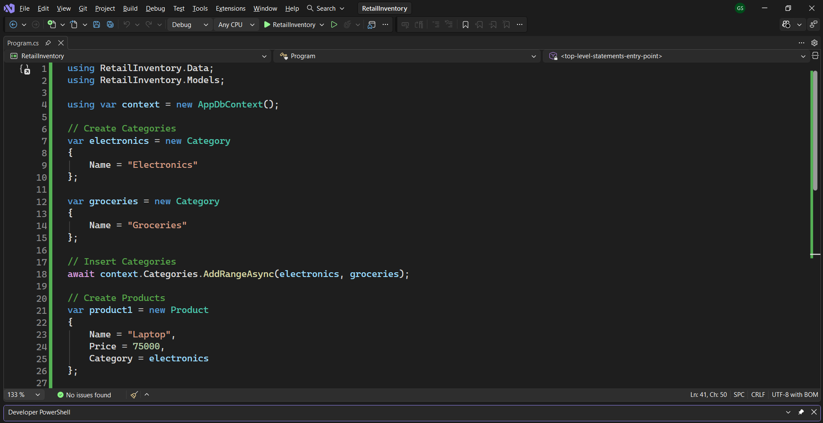

2. Run the App:
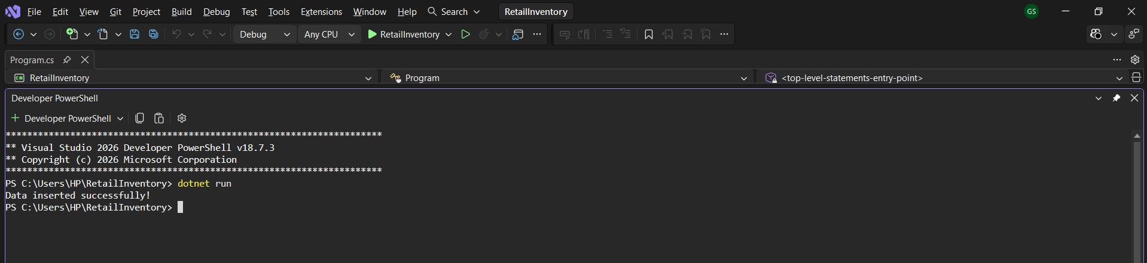

3. Verify in SQL Server:
